FINISH

PALL-X 96

PALLMANN® Pall-X 96 is a 1-component waterborne hardwood floor finish for residential or light commercial applications. This highly durable finish has excellent wear and chemical resistance and provides a deep, rich appearance.

Features
- 1 component
- Exceptional flow & leveling
- Not UV sensitive
- Fast drying

- Low odor
- Four sheens

- Superior build
- High wear resistance

Benefits
- Ready to use, easy to apply
- Extremely forgiving
- Will not amber over time
- Accepts light foot traffic in 3-4 hours
- Non-offensive on jobsites
- Available in Matte, Satin, Semi-gloss and Gloss
- Deep, rich, finished appearance
- Great for light duty commercial and high traffic residential use

Technical Data

Packaging: 1 U.S. plastic gallon
Color: Milky when wet, clear when dry
Odor: Non-offending
Solids: 37% for Satin
Sheens: Matte, satin, semi-gloss, gloss Gloss Level (60˚): 13 GU for matte, 23 GU for satin,
34 GU for semi-gloss, 75 GU for gloss
VOC Content: VOC does not exceed 150 grams per liter
Stability: Min. 12 months*
Clarity: Clear when dry, non-yellowing (not UV sensitive)
Coverage Rate: Approx. 450 – 500 sq ft per gallon Pot Life: Not limited
Drying Time: Approx. 2-3 hours**
Foot Traffic: After approx. 3-4 hours**
Fully Cured: After approx. 7-10 days**
Leveling: Exceptional
Defoaming: Excellent
Application Tools: T-Bar applicator, brush, cut-in pad or roller.
Storage & Working Temp: Store between 50° and 70°F (10-20°C)*
and apply at room temperature 65-75°F (18-25°C) for best results**
* Under optimal storage conditions
** Under optimal application conditions

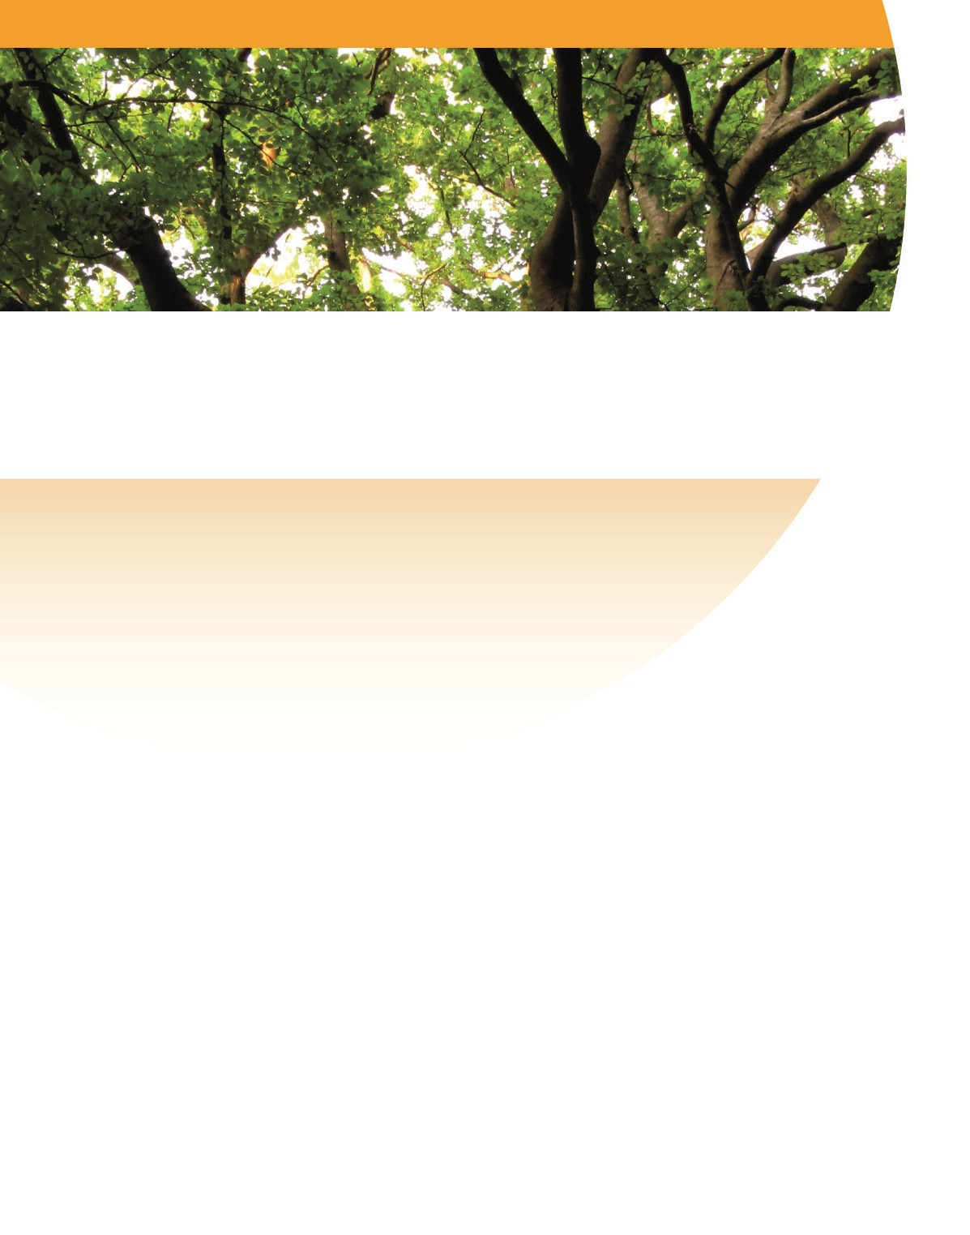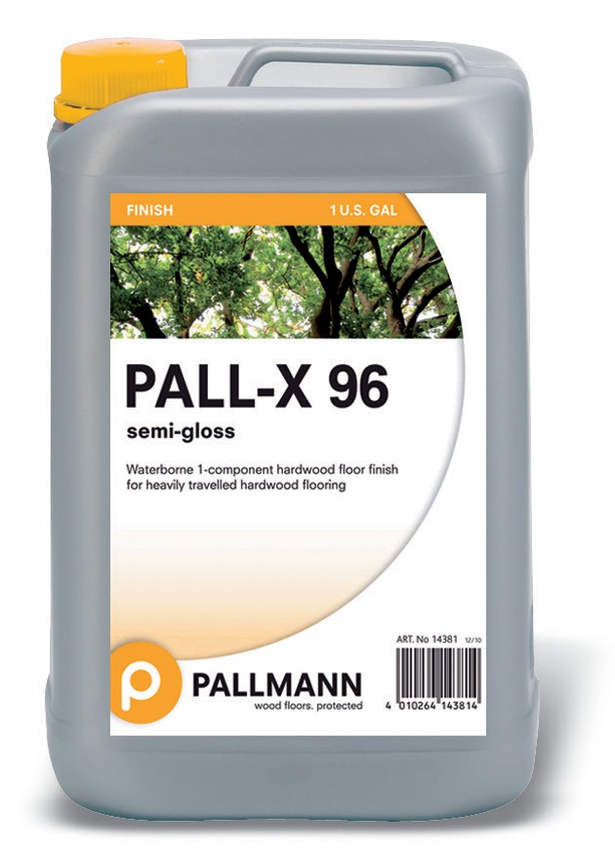

Residential - Light Commercial

Pall-X 96 Directions for Use:

BEFORE USING PLEASE READ ALL DIRECTIONS AND MATERIAL
SAFETY DATA SHEET FOR THIS PRODUCT. For professional use only. This product meets or exceeds all state and federal clean air quality standards and reflects our commitment to personal health, indoor air quality and the environment. DO NOT THIN this product. Call UFLOOR Systems Inc. before using for technical advice if needed. (1-866-505-4810).

RECOATING EXISTING FLOORS
TO ENSURE COMPATIBILITY AND DESIRED RESULTS, TEST PRODUCT ON A SAMPLE BOARD OR IN AN INCONSPICUOUS
JOBSITE LOCATION. Be sure floor is free from wax, oily residue or any contaminate that may include silicone. NOTE: Pall-X 96 will adhere to most stains and finishes after proper preparation and dry times. Stain, sealer and finish results may vary widely depending on the wood species, especially on oily and resinous exotics.
If Recoating a Factory Prefinished Floor check with the flooring manufacturer for advice and instructions for refinishing their prefinished flooring before applying any new finish product. Test an area of the flooring intended to be recoated for proper adhesion. We recommend using the PALLMANN® Pall-X Bond Recoat Adhesion System when recoating factory prefinished flooring.

SANDING AND FINISHING NEW FLOORS
  - Sand and prepare floor in accordance with industry standards.
  - For a stained floor, make your final cut with at least 80-grit paper and screen with 80 – 100 grit screen. (Final sanding grit may influence darkness of stain and visible scratch pattern.) Apply stain according to manufacturer’s recommendations. For an unstained floor, make your final cut with an 80 – 100 grit paper and disc/screen to 120 – 150 grit.
  - Vacuum floor thoroughly.
  - Tack raw, newly sanded wood with a dry, non-treated, lint free tack cloth.
  - The Pall-X 96 System is a three-coat system. 1 coat of a PALLMANN® sealer; and 2 coats of Pall-X 96. A third coat of finish is recommended for residential and commercial areas where heavy wear is anticipated. If floor is to be stained, DO NOT USE SEALER BEFORE APPLYING STAIN. (Pall-X 340 is the recommended Pallmann sealer over stain.)

NOTE: Use separate, clean applicators for both sealer and finish applications.
Recommended Applicators: T-Bar, cut-in pad, roller, brush.

FINISHING
- Shake each container of Pall-X 96 vigorously for approximately one minute making sure all ingredients are well mixed. Failing to shake and mix finish products may result in streaking when the finish is dry. DO NOT ADD WATER TO THE FINISH!
- Use a clean, pre-dampened applicator. Pour a 4” wide line of the finish along the starting wall. Draw the applicator in the direction of the grain at a snowplow angle. Keep a wet edge at all times. (When rolling the finish it is recommended to roll first across the grain then again in the direction of the grain.) Do not overwork the finish. Overworking may cause the finish to “flash” too soon resulting in visible stop marks, lap lines, streaking, etc.
- It is important to maintain the recommended coverage rate of 450 to 500 sq. ft. per gallon. Applying the finish too thin may result in uneven sheen or streaking.
- At the end of each run, turn the applicator toward you and pad out the applicator parallel to the wet edge.
- Feather out all turns.
- Missed areas can be touched up if seen right away.
- Allow the finish to dry 2-3 hours before abrading (for application of 2nd coat). High humidity and/or low temperature conditions may extend the dry time while increased ventilation and airflow may reduce dry time (recommended conditions are 65-75˚F/40-60% relative humidity). Always vacuum and tack thoroughly with a slightly water-dampened Pallmann Microfiber Cleaning Pad after abrading.
- It is recommended that PALLMANN waterborne finishes be well ventilated as soon as dry to the touch. This will accelerate dry and curing time and assure optimal performance of the finish coat.
NOTE: Pall-X 96 will dry to the touch in as little as 2 hours and may be walked on with socks or stocking feet after 3 to 4 hours. Light foot traffic is acceptable after 24 hours and regular foot traffic after 48 hours. Do not place rugs or mats on new finish until fully cured in approximately 7-10 days. Do not use any type of cleaner on the new surface for the first week. Dry mop only with a Pallmann Microfiber Dusting Pad.

INTERCOAT ABRASION
We recommend abrading between finish coats for best appearance. If more than 24 hours have lapsed since the last finish coat was applied you must abrade before applying the next coat. Failure to do so may result in lack of adhesion. Use a 120 - 150 grit screen or delta sheet for best results. Vacuum and tack thoroughly with a lightly water- dampened Pallmann Microfiber Cleaning Pad after abrading.

CURING
The curing process takes approximately 7-10 days (75% cured after 1 day, 90% after 3 days). Wait 2 weeks before replacing rugs and mats. The floor may be walked on after 24 hours, but the floor is susceptible to scuffing or marring prior to fully curing. Do not use cleaner during this 7-10 day curing time. Use only a dry, untreated Pallmann Microfiber Dusting Pad or lint-free tacking cloth during the first week of use. DO NOT use abrasive, acidic or harsh cleaners.

CLEAN-UP
Tools and applicators should be cleaned with water.

MAINTENANCE
Put walk-off mats at all entrance doorways to keep out excessive dirt and grit. Sweep or vacuum daily and damp wipe with the Pallmann Microfiber Mop. The recommended daily cleaner is Pallmann® Hardwood Floor Cleaner.

STORAGE
One component finishes such as Pall-X 96 can be used hours or days after initial opening. Opened containers should be securely recapped and stored in a cool location until re-used. KEEP FROM FREEZING. Finish in previously opened containers should be strained prior to use to eliminate any material coagulation that may occur.

DISPOSAL
Dispose of any unused/unwanted finish or containers in accordance with local, state and federal regulations.

A Brand of

UFLOOR Systems Inc.
Toll free 866-505-4810 | 720-374-4810
14509 E. 33rd Place, Unit G, Aurora CO 80011 ufloorsystems.com

